Reinforcement Learning Tic-Tac-Toe Lab Assignment
https://jinglescode.github.io/reinforcement-learning-tic-tac-toe/

This demo trains two self-play agents (Agent X and Agent O) using a Temporal-Difference, state-valuefunction approach with an epsilon-greedy policy. You train the agents for a chosen number of episodes, then play against the trained Agent X and observe the 'value function' percentages overlaid on the board, which represent the agent's current estimate of its win probability from each candidate next move.

Task 1: Identify the Reinforcement Learning Components
RL Component | Observation / Description
Agent(s) | Two independent learning agents are created: Agent X and Agent O. Each maintains its own value function (a lookup table mapping board states to estimated winprobabilities) and its own hyperparameters (explore probability / learning rate), set independently via the sliders. During training, the two agents play repeatedly against each other (self-play); after training, the user plays interactively against Agent X, which now acts greedily (exploiting) using its learned value function.
Environment | A standard 3x3 Tic-Tac-Toe board. It enforces the rules of the game (legal moves = empty cells, alternating turns, win/draw detection) and returns the resulting state and terminal outcome (win / loss / draw) after each move. The environment is deterministic and fully observable — both agents can see the entire board at every turn.
State Representation | Each state is the full 3x3 board configuration (9 cells, each empty / X / O). Internally this is encoded as a single string/hash so it can be used as a key in the value-function lookup table (a dictionary of state -> value). There is no board symmetry reduction — every distinct arrangement of the board is treated as its own unique state.
Action Space | At any given (non-terminal) state, the available actions are 'place my mark in one of the currently empty cells.' The action space therefore shrinks as the game progresses (up to 9 possible actions on the first move, fewer thereafter) and is state-dependent — only empty cells are legal.
Reward Function | Reward is sparse and only given at terminal states: +1 (value 1) if the agent's move results in a win, 0 if it results in a loss or a draw, and 0.5 as the initial value assigned to every non-terminal state before training begins (not a reward, but the initial 'unknown' estimate). No reward is given for intermediate, non-terminal moves.
Learning Approach | This is a Temporal-Difference (TD) learning approach using a state-value function V(s), similar in spirit to Sutton & Barto's classic Tic-Tac-Toe example (TD(0)). After each game, the agent walks back through the sequence of states it visited during that game (in reverse order) and updates each state's value slightly toward the value of the state that followed it: V(s) <- V(s) + alpha * [V(s') - V(s)], where alpha is the learning rate. Action selection uses an epsilon-greedy policy: with probability epsilon the agent explores (plays a random legal move); otherwise it exploits (plays the move leading to the highest-valued next state).
Exploration Strategy | Epsilon-greedy, controlled per-agent by the 'Explore Probability' slider. Higher epsilon = more random moves = more exploration of new states but weaker play; lower epsilon = more exploitation of the current value function = stronger, more deterministic play (but risk of never discovering better strategies).
Hyperparameters exposed in UI | Number of Episodes (training games played), Explore Probability (epsilon) and Learning Rate (alpha), each set independently for Agent 1 (X) and Agent 2 (O).

Task 2: Training
Episodes | Win % | Loss % | Draw % | Observed Behaviour
100 | 59.00 | 27.80 | 13.20 | Win rate only 59% and loss rate still high (28%) value function is barely trained. Agent frequently fails to block obvious threats and misses winning moves; play is close to random.
500 | 76.20 | 12.40 | 11.40 | Win rate jumps to 76%, loss drops to 12%. Agent is starting to consistently block single, obvious threats and take immediate winning moves, but still gets caught by multi-move traps (forks).
1,000 | 91.50 | 6.60 | 1.90 | Win rate peaks (91.5%), loss falls sharply to 6.6%. Agent reliably blocks threats and takes wins when available; clear jump in tactical consistency compared to 500 episodes.
5,000 | 90.10 | 4.30 | 5.60 | Win rate dips slightly (90.1%) and loss ticks down further (4.3%) performance has plateaued/stabilized rather than improving in a straight line; small fluctuations here are normal training noise, not a real regression.
10,000 | 91.10 | 2.60 | 6.30 | Win rate 91.1%, loss lowest of all runs (2.6%). Agent's losses are now rare behaviour has converged to a strong, close-to-stable strategy, with only marginal gains over 5,000 episodes (diminishing returns).
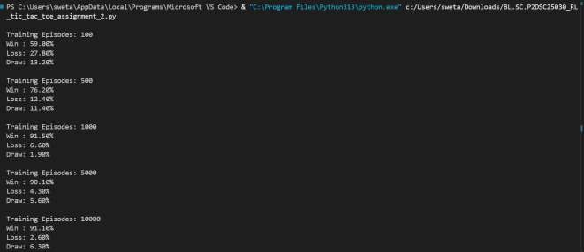

Analysis Questions
- How does the agent's state representation limit or shape what it can learn?
The agent treats every board configuration as a separate state. Symmetric boards
(rotations/reflections) are not grouped together, so it must learn the same strategy multiple times, making learning slower.
- Why is the reward function sparse, and what problem does this create?
Rewards are given only at the end of the game (win, loss, or draw). This creates the credit assignment problem, where the agent must learn which earlier moves led to the final outcome.
- What role does the explore probability (epsilon) play?
Epsilon controls the balance between exploration and exploitation. A very low epsilon may trap the agent in poor strategies, while a very high epsilon causes mostly random play. A moderate epsilon provides the best learning.
- Why does performance improve with more episodes, and why does improvement slow down?
More training lets the agent update its value estimates and improve its strategy. Early learning is fast, but as values converge, additional episodes provide smaller improvements.
- Is more training always better? What are the limits of this approach?
Not always. Since Tic-Tac-Toe has a small state space, performance eventually reaches a limit. This tabular method also cannot generalize across similar states and depends on good parameter settings.
Conclusion
As training increases from 100 to 10,000 episodes, the agent improves from random play to nearoptimal performance. It learns to block opponents, take winning moves, and avoid mistakes, leading to higher win rates and more draws. However, improvements become smaller after extensive training because most important states have already been learned.

